STIX Application Digital Wireframes - Mobile

These are the digital (produced in Adobe XD) wireframes of the essential pages for the “STIX Fun Finder” application. This set is for mobile devices only.

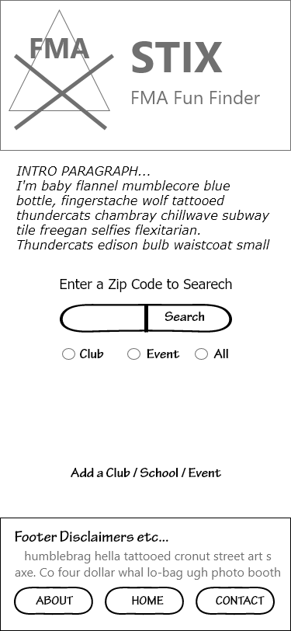Home Page and General Template images for mobile screens

These are the wire frames for the Home page, and for the general template page which is used as a guide for the rest of the site pages.

Search Results and Add Content pages for mobile screens

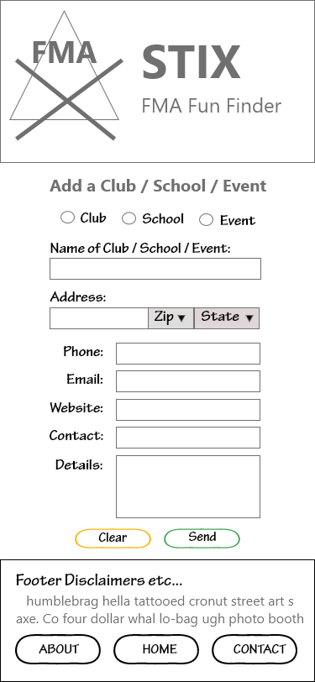

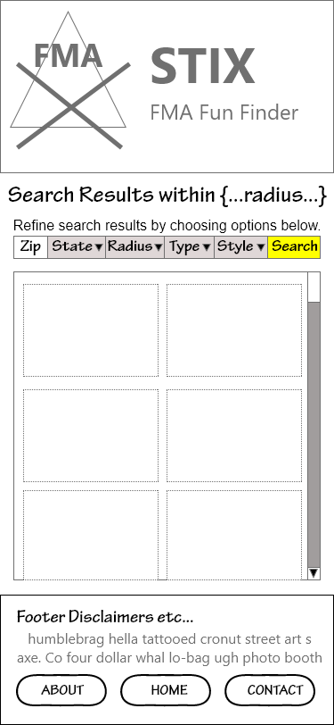

These are the wire frames for the search results page as well as the “Add content” page.

This is the wireframe for the contact us page on Mobile devioces

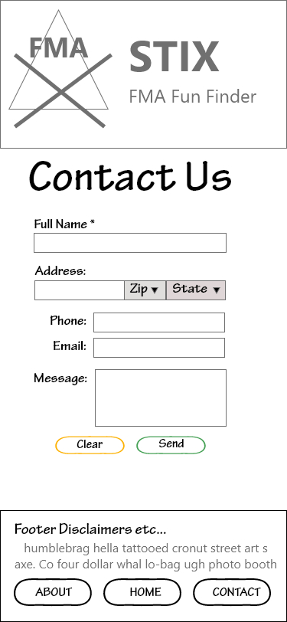

This wireframe represents the look and layout for the contact us page for mobile devices.